1.MATRIX MULTIPLICATION

**Aim**

To write a C program that multiplies two matrices using nested loops and displays the resultant matrix.

**Algorithm**

1. Start.
2. Define matrix dimensions R1, C1, R2, C2.
3. Input or initialize matrices m1 and m2.
4. If C1 != R2, display error and stop.
5. Otherwise, for each row i of m1 and each column j of m2:
   * Compute result[i][j] = Σ (m1[i][k] * m2[k][j]).
6. Print the resultant matrix.
7. Stop.

PROGRAM

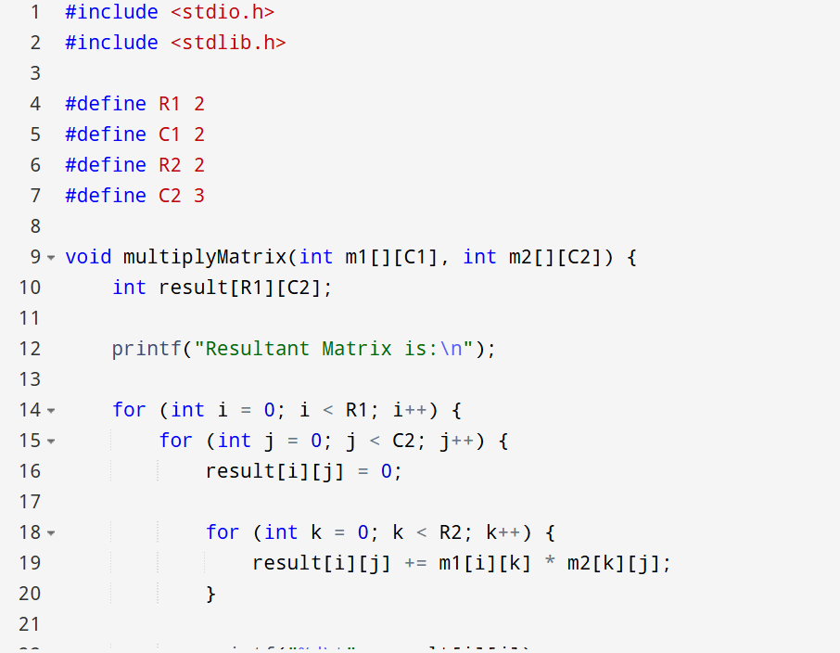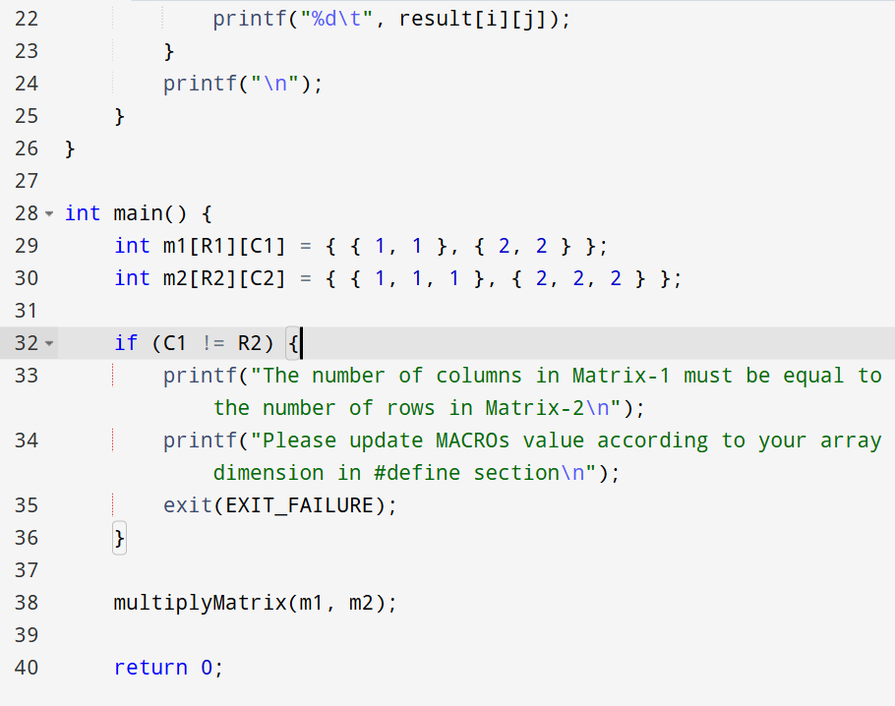

OUTPUT

Resultant Matrix is: 3 3 3

6 6 6